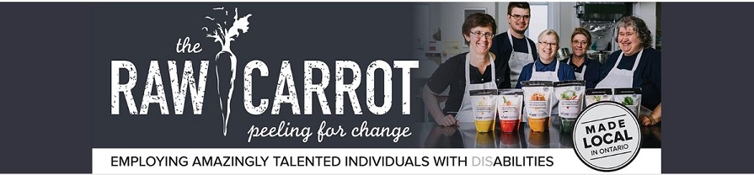
Advisory Board Member Posting
(Mostly Virtual with occasional in-person meeting)
Can one bowl of soup help change the world?

The Raw Carrot is a social enterprise / franchise in Ontario that believes that every person who WANTS to work should have the opportunity for a Hand Up (instead of just a handout) in life!

We partner with churches and non-profits across Ontario to create meaningful employment for amazingly talented individuals living with disAbilities and mental illness.

We’re “stirring up” change in local communities through our delicious, handcrafted gourmet soup.

The Raw Carrot is a small but passionate charity with big dreams to grow. We are looking for members to join our Advisory Board and contribute to the growth of supportive employment opportunities for people on the Ontario Disability Support Program.

As a Christian organization that reaches into our communities with the love of Jesus, the Raw Carrot is looking for Advisory Board members who share our core Christian values and beliefs and bring a diverse perspective to the work that we do.

Do you enjoy looking at the bigger picture?

Duties include:
- To provide input to the Co-Directors in the shape of advice and non-binding recommendations with respect to the current and future strategy of the Raw Carrot.
- To assist in broadening the reach and impact of the Raw Carrot in areas such fundraising, business development and encouraging partnerships; and
- To support specific projects or targeted strategies as required

Current areas of expertise required are:
- Perspective and understanding of persons living with a disAbility (lived experience)
- Business development
- Advocacy
- Fundraising
- Marketing/Communications/PR (particularly food-based / consumer packaged goods)
Commitment
- Believe in the vision of the Raw Carrot and aspire to support the organization’s success
- Aligned with Statement of Belief
- Review internal documents, provide feedback in respective areas of expertise, willing to challenge current thinking that could improve the organization
- Provide unbiased insights and ideas from a third point-of view (not involved in the operation of the business)
- Attend all meetings, or will advise the chair if unable to maintain commitment
- Be an ambassador of The Raw Carrot Soup Enterprise in their community and professional networks
- Commitment required: 2 hours per month, excluding regular meetings and special events
- Participation on committee’s or additional interim meetings, as required
- Act as a resource for the Co-Directors, as per expressed areas of expertise
- Advisory Board Members shall serve a minimum term of two (2) years and maximum five (5) years, with the option to renew for a second term.

To apply:
Please email resume and cover letter including:
- Reasons for wanting to become an Advisory Board member
- Skills that you would like to contribute
to info@therawcarrot.com

*If selected, references will be required

